GIT

Create a new folder and paste the code in that folder

Commands to push in Branch

* git init
* git config –list
* git checkout –b jayprasanth
* git remote add origin <https://github.com/Balaji1302s/IAS-COM>
* git add .
* git commit –m “status”
* git push origin jayprasanth

1.

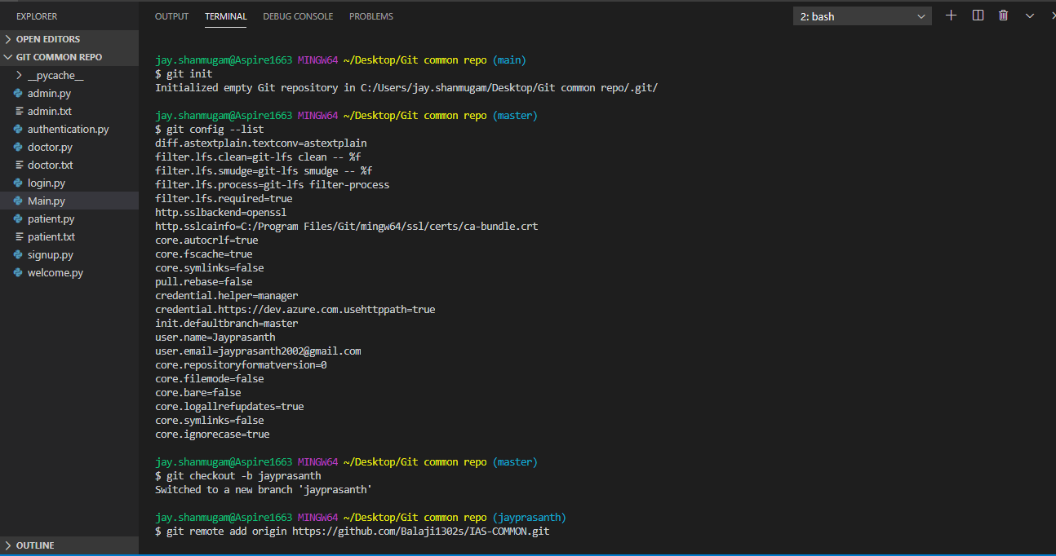

2.

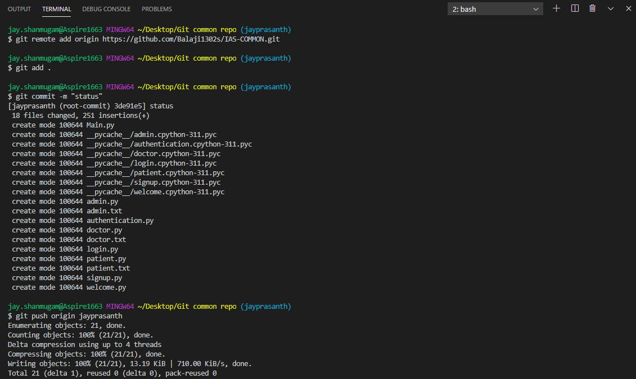

3.

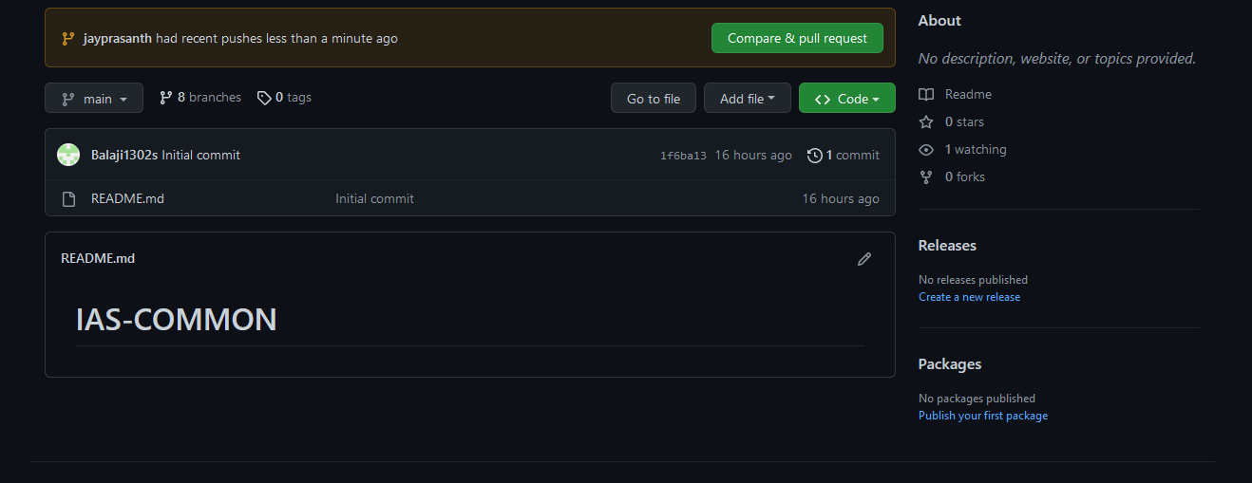

4.

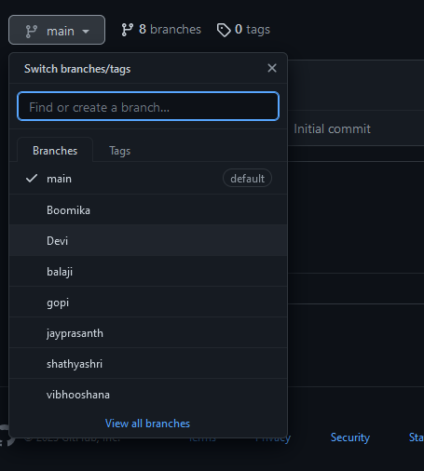

5.

